

Initial Requirements Engineering

**Health Care Information Systems**

Jerifanos Mabika

R1712043

Software Engineering Diploma in Applied Information Technology Project

February 22, 2019

**Initial Requirements Engineering**

**Product backlog**

1. Requirements Engineering
   1. Introduction:
      * Purpose.
      * Scope.
      * Objectives.
      * Definitions.
      * Acronyms and abbreviations.
      * Overview.
   2. Current System description.
   3. Proposed System description:
      * Overview.
      * Functional requirements.
      * Nonfunctional requirements.
   4. Glossary/data dictionary.
2. Object Oriented Analysis.
   1. System models.
3. Object Oriented Design.
4. Testing.
5. Implementation.
6. **Introduction**

The already existing system is a manually operated one, where everything is recorded manually using pen and paper. A lot of paper files are created on daily basis as normal business is undertaken.

* + 1. **Purpose of the system**

This Health Care Information System is going to focus on the data management functions of Centurion Hospital located in Masvingo. The data management department functions include recording clients’ details and their health data. That is: full name, gender, date of birth, address, phone number, race, nationality, known diseases, allergies, medical history, prescription(s), assigned/personal doctor(s).

* + 1. **Scope of the system**

Project is aiming to correct the problems that are being faced by the already existing system. The already existing system is a manual system, where there is no electronic capturing, processing or storage of data, therefore, we want to develop a system that does all the aforementioned tasks electronically (using the computer). The whole system shall be broken down into small modules so that each individual problem will be handle separately and completely. The solved problems/modules will then be interlinked to make up a complete system that achieve all the set objectives. These modules will include data capturing and storage, data processing i.e. searching, viewing, listing, deleting etc and producing a backup.

* + 1. **Objectives**
* Increased speed in capturing clients’ details through computerisation.
* Faster processing of data, which means capturing or accessing data shall be fast.
* Reliable data capturing and storage, no more hustles of reading different kinds of handwritings, dirt record (rubbed/cancelling).
* Security and identification, only authorised persons can do the capturing, amending, viewing and deleting of data.
* Searching and viewing a specific individual’s record.
* Producing a list of all available records.
* Having a backup file will help if there is any form of data loss. Which might be caused by various things, known or unknown e.g. deleting purposely or by mistake, crushing of files or computers.
  + 1. **Definitions, acronyms and abbreviations.**
* i.e. – that is.
* e.g. – for example
  + 1. **Overview.**

Basically, the existing system is primitive, slow, inefficient and has a lot of loopholes. Everything solely depends on the state/mood of the workers i.e. the tidiness of the records, speed of recording and access, safety of records in the file room etc. This is because everything is manually done, therefore computerization takes over more than half of those human done tasks which will bring very significant changes because computers don’t get tired or moody. Capturing and access will be fast, efficient searching and reference etc.

* 1. **Current System**

Centurion Hospital is currently operating the old school way, no computer or computer system is in use. All the data capturing is done by manually recording health data on paper using pens and the records are filed in arch lever or flat files for reference, future use and safe keeping. When a client comes, he/she goes to the data capture clerk who takes down data about the client, i.e. full name, gender, date of birth, address, phone number, race, nationality, known diseases, allergies, medical history, prescription(s), assigned/personal doctor(s). This information serves the purpose of helping the doctors(s) and nurse(s) understand the patient’s history, current situation and health state for current and future treatments. Upon any need, the file room workers have to search for every needed record in the file room and give to the staff members who requested, the doctor or nurse who then make amendments or add information into the file if necessary. After use, the file is then taken back to its location in the file room. Periodically these file room workers must organize all the records in the file room in a certain way that allows them to search and find files quickly whenever they are needed.

* 1. **Proposed System**
     1. **Overview**

The Health Care Information System software will be designed to eliminate redundancy, slow data capture and access service delivery, accountability issues upon mistake/errors, safety and security of data about clients which all will improve the quality of work and effectiveness of the business.

* + 1. **Functional requirements**

The system shall have access levels which will determine what a user can do. A Data capture clerk can only enter data about clients into the system, while a supervisor can amend or delete records, the Administrator can create users, set access levels and deleting users.

I shall develop programs that allow entry, searching, editing, deleting, listing of client records in a secure electronic file. This shall allow fast data capturing, searching facility allows viewing an individual client, editing facility allows making corrections of any sort, deletion allows removing a record out of the system and the listing facility allows viewing all the records available. I shall also try to create a systems backup facility to cater for unforeseen circumstances.

* + 1. **Non-functional requirements**

The system shall be:

* Reliable – it shall allow accessing all the records already entered whenever they are needed.
* User friendly – the interface will be easy to use and understand.
* Fast – there is improved speed on all tasks since the is use of computers and efficient programs.
* Secure – data about clients will be electronically stored and it will be protected from unauthorized access or theft.
* Compatible with any windows operating system, the system is lite and not resource hungry.
* Better presentation of records, a good layout on the view and print and in the end neat lists and or records are produced.

1. **System model.**

**Use case Diagrams**

1. **The Administrator**

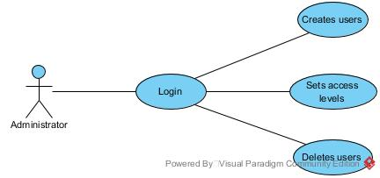

Figure 1

**Description:**

1. **Login** – the Administrator has to login in order to get into the system.
2. **Creates users** – the Administrator can create new users.
3. **Set access levels** – he/she can set the access levels of the created users, which determines what a user is privileged to do.
4. **Deletes users** – only the Administrator can delete users.
5. **The Supervisor**

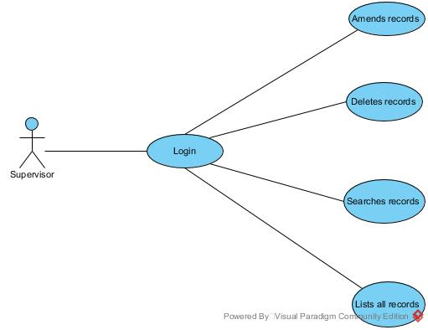

Figure 2

**Description:**

1. **Login** – The Supervisor first has to login to get access into the system.
2. **Amends records** – he/she is the only person who can amend records if there were capturing mistakes or corrections needed.
3. **Deletes records** – only the supervisor can delete records.
4. **Searches records** – he/she can search individual records in the database.
5. **List all records** – he/she also has the privilege to list and view all records in the database.
6. **The Data capture clerk**

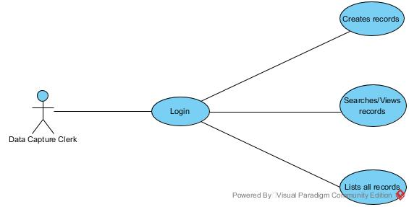

**Description:**

1. **Login** – the Data capture clerk has to log in first in order to use the system.
2. **Creates records** – every time data about clients is captured, a new record is created. And it is only the Data capture clerk who can do that.
3. **Searches/views records** – the system allows him/her to search an individual record and view it.
4. **List all records** – the system also allows the data capture clerk to list all records in the database file.